**Student’s Project**

**MOROCCO**



**A New Vision for Fighting Bullying**

**at School**

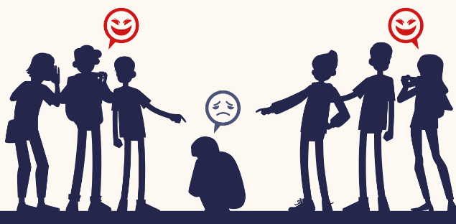

**The researcher : Boufaris Sara**

Supervised by : Prof. Mohamed Fettah

School: Moulay Ismail High School

**Outline**

1. **Part One (Theory) ...........................................................**
2. **Introduction.**
3. Definition and forms of bullying.
4. Overview of the prevalence and impact of bullying in schools.
5. **Challenges in fighting bullying in schools.**
6. The impact of bullying on students' education, attitudes, and social well-being.
7. Case studies to highlight the experiences of some victims.
8. **Innovative solutions for combating bullying in schools.**
9. Implementing social-emotional learning programs.
10. Using technology to monitor and prevent cyber-bullying.
11. Establishing peer mentoring and support groups at school.
12. Engaging parents and the wider community in anti-bullying efforts.
13. **Part Two (Practice) ........................................................**

* **Doing surveys and interviews with parents, students, teachers, and professionals.**
* **Making a video to share my own views about this topic.**

**Abstract**

**Bullying remains a significant challenge in schools across the globe. It affects students’ emotional well-being, academic performance, and social development. The pervasive nature of bullying creates an environment of fear and anxiety which undoubtedly hinders students from reaching their full potential.**

**Clearly, this research explores the limitations of current anti-bullying approaches and identifies innovative strategies to address this problem. It also emphasizes the importance of focusing on prevention, intervention, and accountability to create a safer and more inclusive school environment. Indeed, by shifting away from reactive measures to proactive solutions, schools can better equip themselves to tackle bullying at its roots, and so ensure long-term improvement.**

**Ultimately, the research presents a comprehensive framework for implementing anti-bullying strategies in schools. By integrating these strategies, schools can create an environment that supports students not only academically but also socially and emotionally. Moreover, the research clarifies the importance of engaging parents, teachers, and the broader community in building a culture of respect and empathy within schools. Because such collaboration and cooperation is an essential tool to foster a healthy school environment.**

"The ideal society is the one where people support and respect one another, ensuring that no harm comes to any individual through the actions of others."

Al-Farabi